# Technical Test:

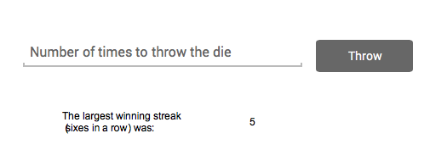

Create a simple webpage that allows the user to input the amount of times to throw a single die.   
  
The application should then ‘throw’ the die for the requested amount of times and record the largest winning streak. A winning streak is the amount of times a six was thrown in a row.   
  
For example…

Input 10

Press ‘Throw’

The application will then simulate the number of throws…

4, 3, 6, 6, 1, 3, 5, 6, 4, 1

The application should then output the largest winning streak. In this case, 2.

Another example:

Input 20

4, 5, 3, 6, 6, 4, 3, 5, 1, 2 4, 6, 6, 5, 4, 3, 1, 6, 6, 6

The application should then output 3. Since 3 was the most sixes that was thrown in a row.

Limit the number of throws to about 1 million. You do not have to show the ‘throws’, only the resulting streak (see above screenshot)